**Project Planning**

**Project Name:** Medical Center Management System.

Members: Alban Plakalliu, Gleris Xhoxha, Erlis Ciko, Klei Qorri, Erblin Boletini, Deni Mekollari

Real start and end days: 9.03.2025-30.05.2025

Estimated start and end days: 15.03.2025-15.06.2025

Real total days: 83 days

Estimated total days: 93

|  |  |  |  |
| --- | --- | --- | --- |
| Nr | Activity | Duration(Days) | Dependencies |
| A | Proposed topic for project | 7 |  |
| B | Feasibility Study | 2 | A |
| C | Project Description | 5 | B |
| D | Sketch Designs | 5 | B |
| E | Requirements (Functional,  Non-functional, Domain) | 7 | B, C |
| F | User scenarios  Use cases | 7 | D, E |
| G | Activity Diagram  State Diagrams | 14 | F |
| H | Sequence Diagrams | 7 | G |
| I | Class Diagram  Component Diagram | 7 | H |
| K | Detailed Design | 5 | D, F |
| L | Programming | 20 | G, H, I, K |
| M | Testing | 5 | L |
| N | Installation | 2 | L, M |

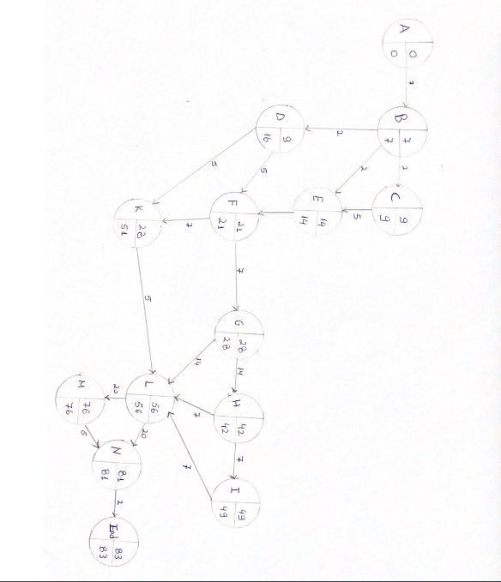

Gant Charts (Optional)

